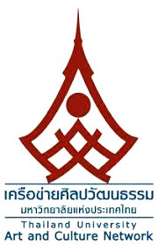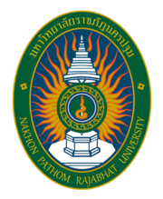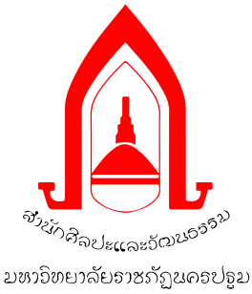

Registration and Transfer Money Form for Participants
The 9th International Conference of Thailand University Art and Culture Network
11th -13th February 2019
at Nakhon Pathom Rajabhat University

Notice : Please fill out this form completely and mark in the selected box. (elaborate handwriting or printing)
1. Participant Information
First Name....................................................................................Last Name................................................................................................
Position Title...............................................................................Organization………...................................................................................
Address……………………………………………………………………………………………………………………………………………………………,…..…....................
…………………………………………………………………………………………………………………………………………………………………………,……......................
Telephone........................................……………………..……........... E-mail: …………………………………….…………….………….…………………………

Attend the Conference ICAC2019 and Present
Presentation Title ……………………………………………………….……………………………………………………………………….………………………………….
…………………………………………………………………………………………………………………………….…………………………………………………………………….
Article Field…………………………………..………………………..…………………………………….…………Article code: …………………………………………

Type of presentation Oral Poster
Dissemination of academic work Yes No
I welcome the publication of documents Proceedings Journal
Book proposal E-Book

Attending the Conference but Not Presenting

Choose the Type of Food Normal Vegetarian Halal Food

2. Registration (registration rate 1-31 January, 2019)
Researcher/Academician/General Public and Student is out of Network, must pay for 1,500 baht
Researcher/Academician and Student of Nakhon Pathom Rajabhat University and Network
(except registration fee)

3. Paying of the Registration Fee
1. Please transfer money to Nakhon Pathom Rajabhat University account, Krungthai Bank, Current Account 986-5-34173-5
2. Please attached the completed form with Pay-In Slip (receipt / application for transfer money)
at E-mail : arts_culture@npru.ac.th by 1 February, 2019

4. Issuing Receipts
Institute Name of Issuing Receipts:...............................................................................................................................................................
Address: .............................................................................................................................................................................................................
(** The receipt will be given to the authors at the venue on 11-12 February 2019)

............................................................ Signature of registrant

(……………………………………….………… )
Date / /
* Please check the information correctly and completely

